**Ben Brandhorst**

**October 25th 2019**

**Database Security**

**SDEV 350 7980**

**Professor Ivan De Los Santos**

**LAB 1 – AWS Educate and SQL Developer Setup**

**Figure 1 – (AWS ACCOUNT SETUP) This is a screen capture showing the status of the AWS Account. This was setup earlier in the week, hence the lower amount of remaining credits.**

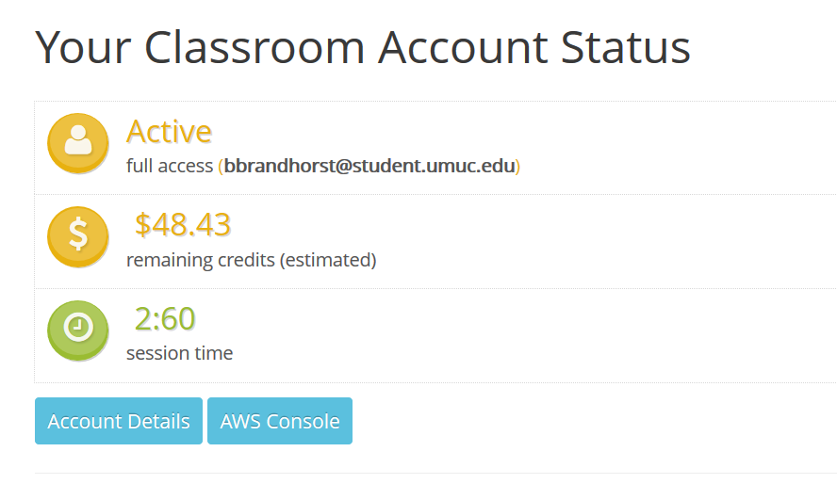

**Figure 2 – (AWS ACCESS INFORMATION) This is the AWS Access information. This shows the requisite information the lab calls for.**

**AWS Access**   
   Session started at: 2019-10-25T15:00:16-0700  
   Session to end  at: 2019-10-25T18:00:16-0700  
   Remaining session time: 2h57m53s  
  
   Term: 74 days 19:11:38

**Figure 3 – (CONNECTIVITY AND SECURITY) This shows the RDS endpoint and port for the RDS instance. Here you can see that I’ve set these things up correctly.**

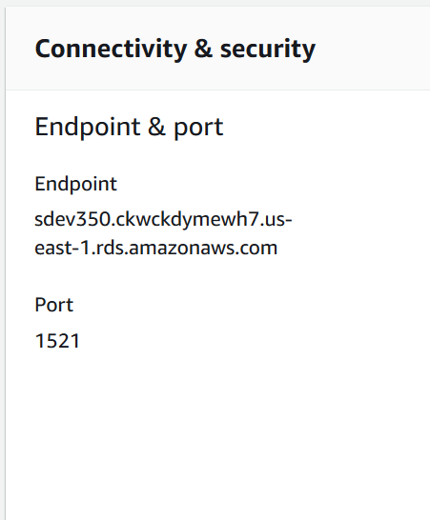

**Figure 4 – (RDS INSTANCE CONNECTION) This screen capture demonstrates a successful connection to the RDS instance. You can see both the username and password are stored and the connection details.**

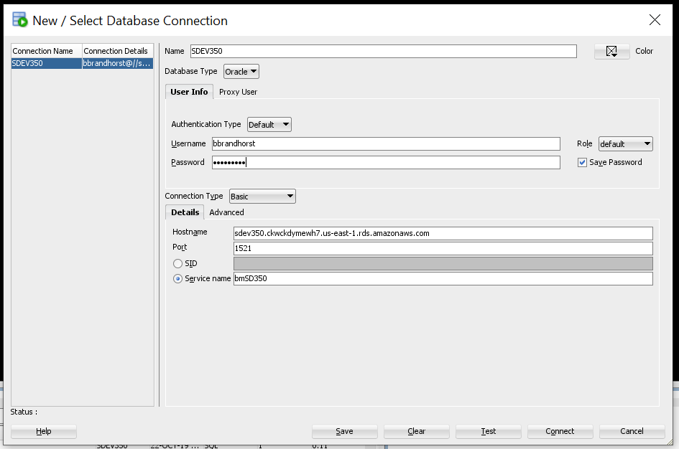

**Figure 5 – (TABLE CREATION) This shows the successful creation of a simple table named CoolKids. The table created has four columns as was specified in the lab instructions.**

